Operators:

&operator used to create a reference variable, to get the address of the variable, and used to pass a reference to a f(x).

*operator is used to create a pointer variable, dereference a pointer variable and multiplication.

for long v *i=v[i]; pointer

Generic Algorithms:

Generic algorithms: are templates, utilize iterators, and they operate on collections

The copy generic algorithm would be used to print all the values of a vector without modifying the vectr.

The accumulate generic algorithm would be used to multiply all the values of a vector for a single result.

The following generic algorithms allows you to modify their “standard operation” by adding a f(x) of my own design: sort, accumulate, transform.

Different Methods (cin) (?):

cin.ignore clears input buff cin 4 all remaining input

cin.clear( ) clears any errors, cin to be “good”

=delete isn’t allowed at th end of constructor declare

C++ methods/f(x) members: when defined outside the class, require scope resolution operators; are invoked in the context of a classes’ instance and they are automatically provided the this pointer.

Classes???

Friend functions are declared in a class

Constructs:

lambda construct is a f(x) and can be invoked like 1.

Navigations through maps and vectors:

for auto i=v.begin( );… where v is a vector<long>. i is a vector<long>::iterator type;

map m={{1,2},{3,4},{5,6},{7,8}}; m.size( )=4;

m[5]=6; cause 5 is the key and 6 is the value.

m.count(int) how many times the key int is in m

if k isn't a value in m m[k]=var put it in the map.

Types:

auto declaration CANT: determine a variable's type at run time and compile time. not actually set a variable's type, isn't a way around the type system,is restricted to only built-in types like long or string.   
auto type declaration can determine a variables type, doesn't create variables as references explicitly requested and doesn't create constant variables unless explicitly asked. The compiler will try to deduce the type of variable.  
v_cnt_++ === (this->v_cnt_)++;

ans+=(*i).second===ans+=i->second

size_t type is an unassigned integer.

for auto i=m.begin( );… where m is a map<long,long>. i is a pair<long,long> type

String Ops:

You can output to ostringstream variable sout using << operations.

string::nops means no such position in string.

NxtPgeF(x):

F1(L1: boolstoalpha; L2:1; L3/5:NA; L4:smaller;)

F2(L1:TYPES L2:1; L3/4:5; L5:0; L6:36;)

F3(//L1wrtL3:0,1,2,3,NA; L2:3; L3:2; L4:3)

F4(L1TYPE:string;L2: 1:1: L3:4; L4: 2:2)

F5(L2:5;L3:6;L4:NA; L4 TYP val=string)

F6(L1:TYP e:long; L2:NA; L3:1; L4:6; L5:0; L6:2)

F7(L1:NA; L2:cde; L3:3; L4:bca; L5:2; L6:1)

F8(L2: The three-arg constructor with a default on the third arg; L3:(100,300,unknown); L4:unset;)

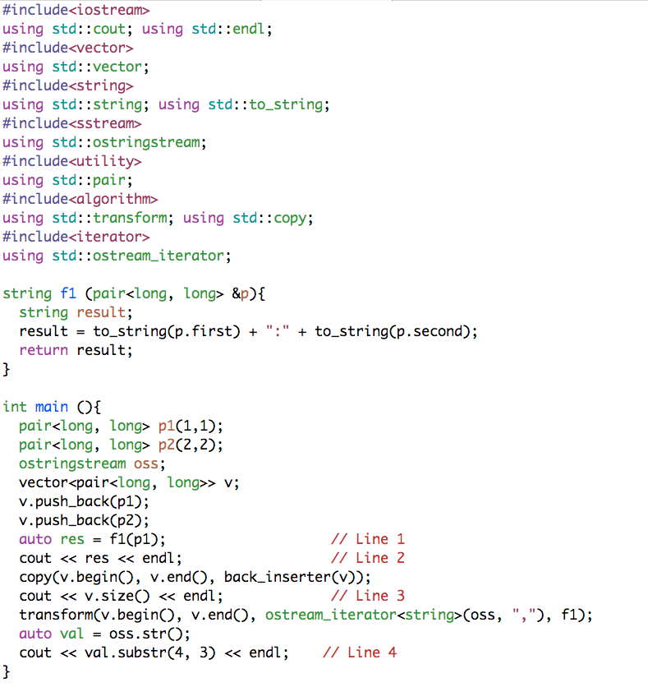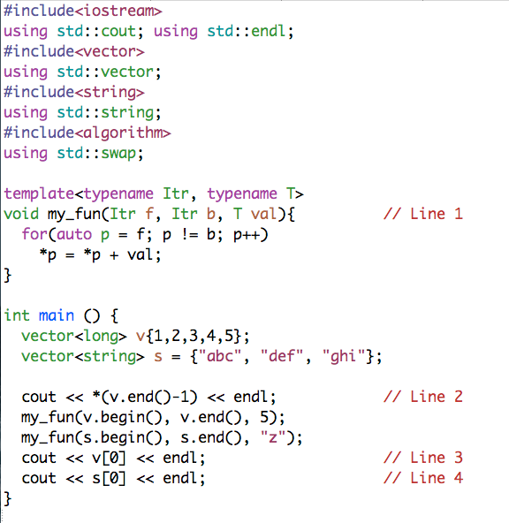

F5

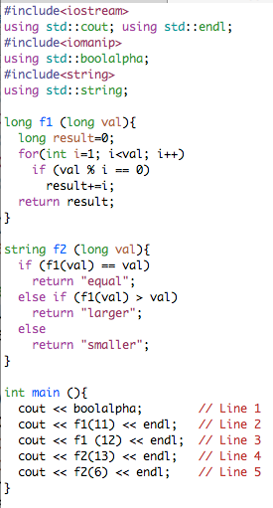

F1

F4

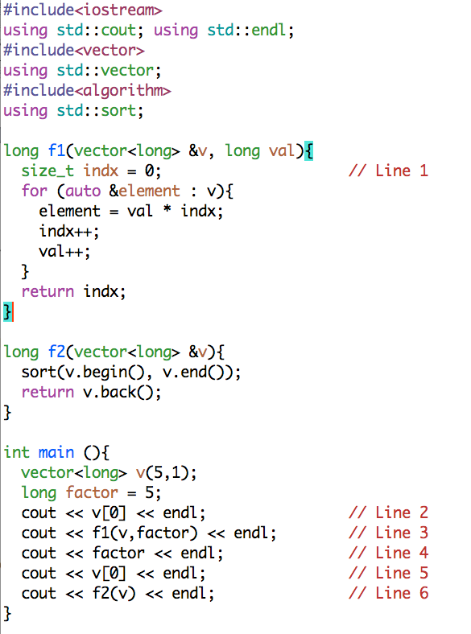

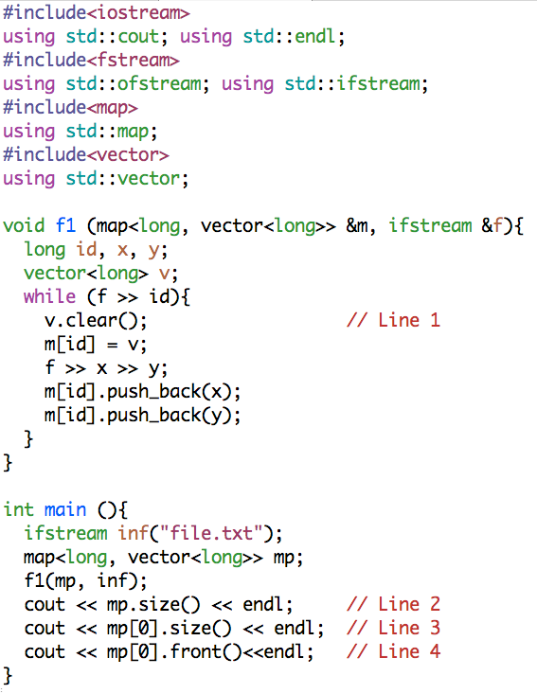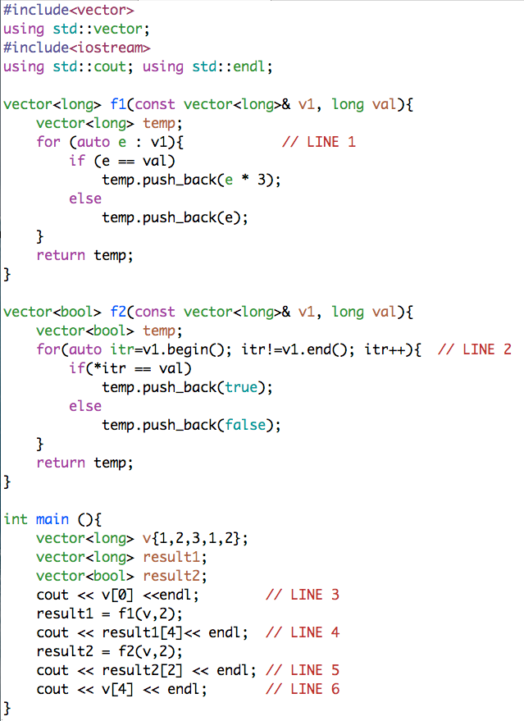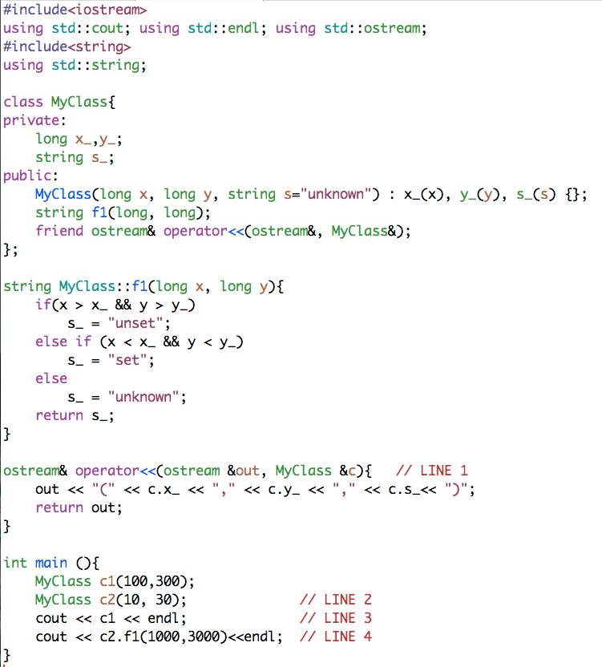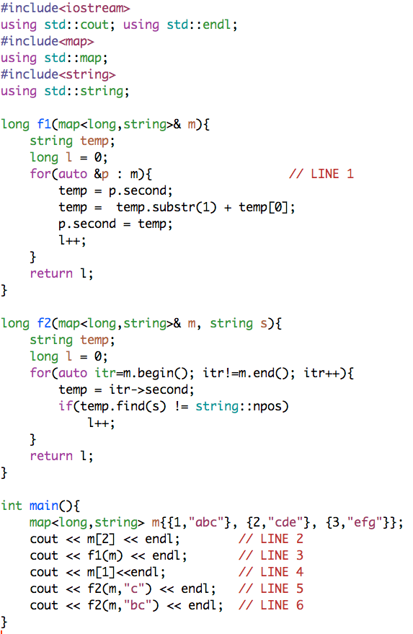

F6

F3

F2

F8

F7